EXPERIMENT NO 3
The stakeholders have conflicting views on the user interface design for an E-Commerce mobile app. Create a prototype using Figma tool to discuss with the stakeholders to get their feedback and approval.

Aim
To create an interactive prototype of an E-Commerce mobile application using the Figma tool and present it to stakeholders to collect feedback, resolve conflicting UI design preferences, and obtain approval.
Procedure
- Open the Figma tool and create a new design file.
- Create mobile app screens such as Login, Home, Product Listing, Product Details, Shopping Cart, and Checkout.
- Design the user interface with suitable colours, fonts, buttons, icons, and product images.
- Create multiple design variations to address the different preferences of stakeholders.
- Connect the screens using Figma's Prototype mode to enable interactive navigation.
- Share the prototype link with stakeholders for review and discussion.
- Collect feedback, compare suggestions, make necessary changes, and finalize the UI design based on stakeholder approval.
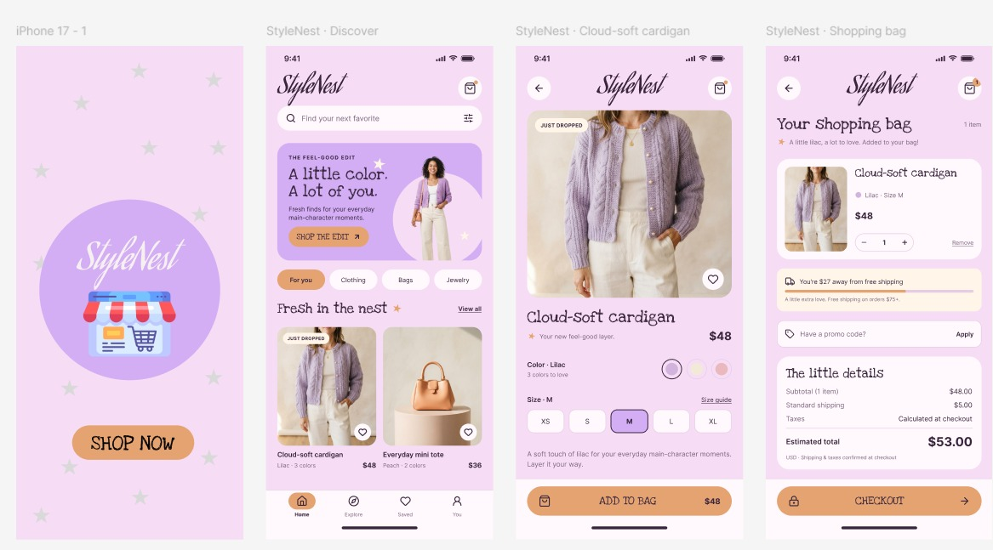
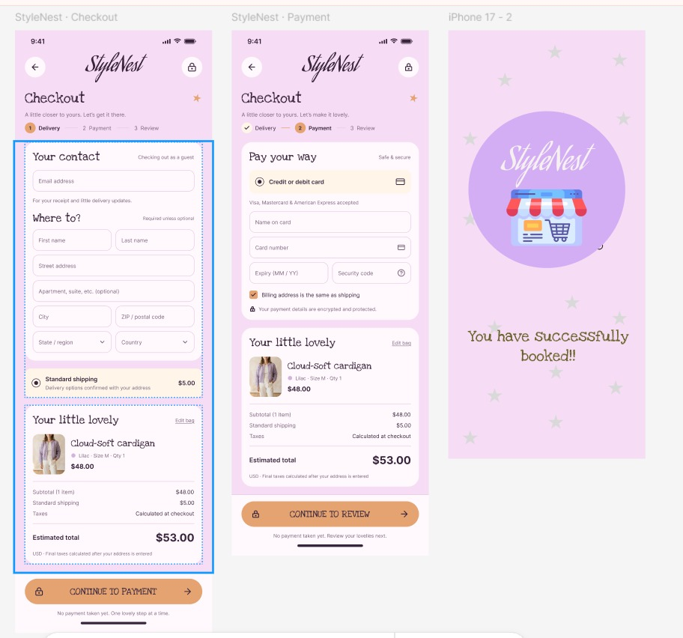

Result
An interactive E-Commerce mobile app prototype was successfully created using Figma. Stakeholder feedback was collected to resolve UI design conflicts, and the design was refined to improve usability and achieve a mutually approved interface.

